ETCO₂ – why would that be a minimum
mandatory monitoring standard

Dr. N. Selvarajan MD (AIIMS), HOD of Anaesthesiology,
KMCH, Coimbatore

a. What is ISA’s view regarding ETCO₂ as a minimum mandatory standard
b. Physics behind ETCO₂
c. Various types
d. How is it helpful in crisis?

Introduction:
Measurement of exhaled CO₂ is called capnometry. This has become a part and parcel of general anaesthesia with endotracheal tube for major surgeries. ETCO₂ monitoring has proved to be very useful not only in endotracheal anaesthesia but also in other fields. In Greek, kapnos means smoke and graphein means to write. Capnometer is a device that measures CO₂ concentration and displays on an analogue or digital scale whereas capnography is the graphic record of instantaneous CO₂ concentrations in the respired gases esp. during exhalation. This correlates well with the arterial CO₂in most patients (ETCO₂ is 2 – 6mmHg less than PaCO₂).
CO₂ production and elimination:
Oxygen Lungs body tissues cellular metabolism

CO₂Transported to lungs CO₂ production
Breathed out in exhalation into the atmosphere (ETCO₂)
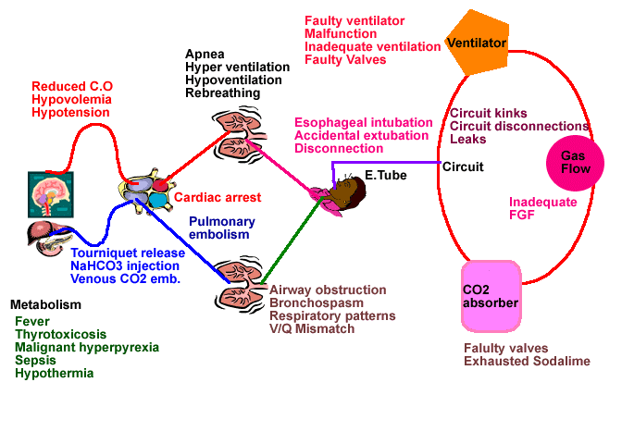
Diagram depicting problems recognizable with capnography

PHYSICS behind ETCO₂ monitors:
- Chemical method – calorimetric method

- Physical methods
- IR spectrometry
- Raman Spectrometry
- Mass spectrometry
- Photo-acoustic Spectrometry
- Molecular Correlation Spectrometry

Infra – red spectrometry:
Most popular method of measuring CO₂. First CO₂ measuring and recording apparatus was by Luft in 1943. CO₂ selectively absorbs 4.28 µm IR light. Amount of IR absorbed is proportional to the concentration of CO₂. Comparing the absorption with a known standard, the concentration of CO₂ can be calculated. Very compact and less expensive. Measured value is expressed in % or mmHg or Kpa.
Types of capnography:
- Main stream capnography
- Side stream capnography

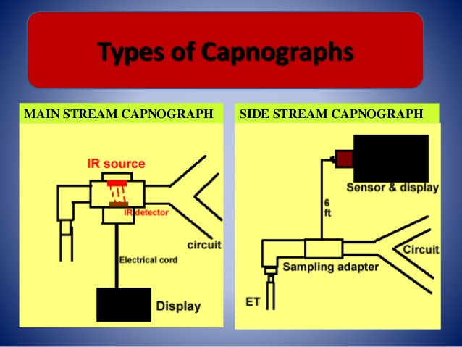

Main stream capnography:
Advantages:
- No need for tubing and no calibration required
- Fewer disposable items
- No theatre pollution & sample gas contamination unlikely
- Faster response time and more accurate

Disadvantages:
- Warm up time longer
- Chance of facial burns & pressure injury
- Heavy sensor can exert traction on the ETT
- Sensor vulnerable to breakage
- Can’t use it for spontaneously breathing patients via face mask
- Can’t be used for gases other than CO₂
Side stream capnography:
The measurement is done away from the ETT. A tiny pump aspirates gas samples from the patient’s breathing circuit to the monitor through a fine long tubing. Sensor is located in the main unit. Sampling flow rate is usually around 50 - 200 ml/min.
Advantages:
- Warm up time quicker
- No dead space
- Can monitor spontaneously breathing patients also
- Sampling device not heavy and hence no traction on ETT
- Single sampling line detects O₂, CO₂, N₂O & agent
Disadvantages:
- Sampling tube may get kinked or blocked
- Response time is longer and less accurate
- Risk of theatre pollution
- Have to be cautious during low flow anaesthesia
- Needs more disposables
Microstream capnography:
- Principle: molecular correlation spectroscopy
- Few of the latest capnographs use this technology
- Sampling rate is around 50 ml/min and hence theatre pollution is negligible.
- Fast, accurate and portable
- Ideal for neonates and children
Ultra compact microrotor technology
To measure CO_{2,} nitrous oxide and five anaesthetic agents
Flow of 50ml/min to monitor CO_{2,} even if breath rate is up to 150bpm
Long life filterline.
NOMOLINE

Main stream sensors
New development in main stream sensor technology and it has overcome many disadvantages associated with earlier models such as heavy weight, bulky size, facial burns and increased drag in ET tube .
CAPNOSTAT 5
Miniaturized main stream multi-gas monitor
The sensor in the mainstream analyser has been made light weight.

Parts of a capnograph
Phase I : Anatomical and apparatus dead space
Phase II : Mixture of anatomical and alveolar dead space

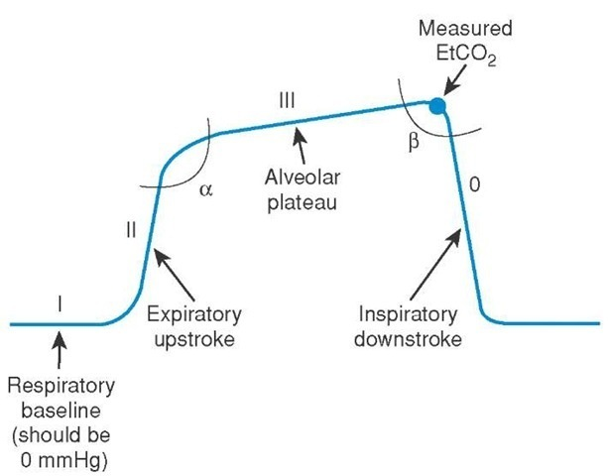
Phase III : Alveolar plateau
Phase 0 : Down slope to zero (inspiration)
Alpha angle : angel between phase II & III – indirect indication of V/Q status
Beta angle : angle between III & 0. Increase indicates rebreathing
How to analyse CO₂ waveforms
- Baseline
- Height
- Shape
- Frequency
- Rhythm
Elevated insp. baseline (Phase I)
This usually means rebreathing
- Exhausted CO₂absorber
- Inadequate inspiratory flows
- Incompetent valves
- Sudden increase in both baseline and ETCO₂ means contamination of sample cell with water, mucous or dirt

Prolongation or slanting of expiratory upstroke (Phase II)
Due to obstruction to exhaled gas flows

- Bronchospasm
- COPD
- Kinked ETT

Leaks in the breathing system
Increase in height or the plateau
- Increased BMR
- Malignant hyperthermia
- Hypoventilation

Decrease in height or the plateau
- Decreased BMR
- Decreased cardiac output
- Hyperventilation
Curare cleft
Return of spontaneous breaths in a paralysed patient

Camel curve
This capnograph occurs due to
- sampling leaks in the sampling tube cracks
- a loose connection between sampling tubes and the monitor
- breaks in the water filter of the carbon dioxide analyzer
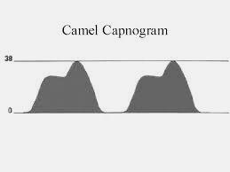
- differential lung emptying of the lungs transplanted lung and diseased lung
- In addition, a dual capnogram can result during endobronchial intubation and in patients with severe kyphoscoliosis

Cardiogenic oscillations
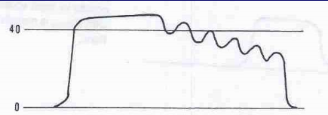
Sudden drop or absent CO₂
- Oesophageal intubation or accidental extubation
- Disconnection or total airway obstruction
- Apnoea or cardiac arrest or circuit disconnection
- Pulmonary embolism
- Water blocking sampling tube

How is ETCO₂ helpful in a crisis
- ETCO2 gives an estimate about the alveolar CO₂ concentration.
- Shape of the curve helps to determine various conditions like
  - Adequacy of spontaneous respiration
  - Integrity of anaesthetic apparatus
  - Accidental oesophageal intubation
  - Adequacy of fresh gas flows in closed circuit
  - Weaning off of muscle relaxants
  - Adequacy of cardio pulmonary resuscitation
  - CO₂ gradient between artery (PaCO₂) and alveolus (ETCO₂) indicates the dead space
  - Useful monitor while providing sedation in OT or remote areas
  - Postoperatively to know the adequacy of ventilation
Why capnography should be made mandatory
- For confirmation of ETT placement
- For prevention or avoidance of anaesthetic mishaps
  - 93% of catastrophies could have been prevented with a combination of pulse oximeter & capnograph.
- Non-invasive monitor ; easy to apply and interpret
- Spo2 takes 5 minutes to reflect changes in oxygen saturation whereas Etco2 reflects changes almost instantaneously! Oesophageal intubation, cardiac arrest, pulmonary embolism, circuit disconnection, adequacy of CPR and return of spontaneous circulation (ROSC) will all be picked up instantaneously by capnograph.
- Was made mandatory by ASA as far back as 1999. It was extended to iv sedation in peripheries also.
Stand of ISA:
ASA made ETCO₂monitor for endotracheal anaesthesia as early as 1999. This was revised in 2010 to include it for moderate and deep sedation. A high level committee by the ISA, discussed various pros and cons of making ETCO₂ a mandatory monitor. Taking into consideration the economic factors and variety of hospitals present in this vast country, they concluded that ETCO₂ is a desirable monitor and not mandatory monitor for general anaesthesia. Recently the State of Telengana promulgated an ordinance that ETCO₂should be a mandatory monitor for anaesthesia for laparoscopic surgeries. Hopefully ISA will also make this very useful monitor mandatory for anaesthesia and iv sedation.

CONCLUSION:
- Capnography is a very useful and much required monitor for anaesthesia, sedation and CPR.
- Eyes don’t see what the mind doesn’t know. All of us should be very familiar with the different wave forms and their interpretations so that even if we have the monitor, the interpretation is done by us instantaneously.
- Considering the various financial constraints of different types of hospitals, ISA has made this a desirable monitor and not mandatory monitor. There is no doubt, ETCO₂ will be made a mandatory monitor in the near future.
- Beware of the falsely reassuring statement “His breathing must be adequate – the sats are OK”. Saturation only tells us about the oxygenation and adequacy of ventilation can only be assessed with ETCO₂ or PaCO₂. So use ETCO₂ to assess ventilation.
- SpO₂ takes 5 mins to reflect changes whereas ETCO₂ almost immediately!

REFERENCES:
- www.capnography.com
- Bhavani Shankar K, et al. Capnometry and anasthesia. Review article. Can J Anaesth 1992
- Bhavani Shankar K et al. Terminology and the current limitations of time capnography. J Clin Monit 1995
- Shankar KB et al. The arterial to end tidal carbon di oxide tension difference during anaesthesia for tubal ligations. Anaesthesia 1987
- Tinker et al. Anesthesiology 1989;71:541­6
- Joel Weaver, DDS, PhD, Editor-in-Chief The Latest ASA Mandate: CO₂ Monitoring For Moderate and Deep Sedation: Anesth Prog. 2011 Fall; 58(3): 111–112.
- Silvestri S, Ralls GA, Krauss B, et al. (May 2005). "The effectiveness of out-of-hospital use of continuous end-tidal carbon dioxide monitoring on the rate of unrecognized misplaced intubation within a regional emergency medical services system". Ann Emerg Med 45 (5): 497–503. doi:10.1016/j.annemergmed.2004.09.014. PMID 15855946.
- Lightdale JR, Goldmann DA, Feldman HA, Newburg AR, DiNardo JA, Fox VL (June 2006). "Microstream capnography improves patient monitoring during moderate sedation: a randomized, controlled trial". Pediatrics 117 (6): e1170–8.doi:10.1542/peds.2005-1709. PMID 16702250.
- Burton JH, Harrah JD, Germann CA, Dillon DC (May 2006). "Does end-tidal carbon dioxide monitoring detect respiratory events prior to current sedation monitoring practices?". Acad Emerg Med 13 (5): 500–4.doi:10.1197/j.aem.2005.12.017. PMID 16569750.
- . Sanders AB, Ewy GA, et al. Expired CO₂ as a prognostic indicator of successful resuscitation from cardiac arrest. Ann Emerg Med 1985; 3(2), 147-149.

