Sepsis- a Clinical Update
Dr. Joseph ., Consultant Anaesthesiologist
Balaji Hospitals
Chennai

Introduction
Sepsis is one of the leading causes of in-hospital mortality and morbidity among medical and surgical patients.Severe sepsis accounts for one in five admissions to intensive care units [ICUs] and is the leading cause of death in the non-coronary ICU.[1] Unfortunately, the outcome of sepsis has remained unacceptably high to the tune of 30%–40% despite the development and availability of an increasing array of higher generation antibiotics with broader spectrum of coverage and advances in intensive supportive measures.[2] Althoughwell recognized as an important health issue globally, most of the epidemiological data regarding the incidence and mortality of sepsis have emerged from western countries and puts the overall incidence of sepsis ranging from 10% to 30% with mortality ranging from 10% to 56%.[2,3] Available data from India suggest that the overall mortality of all septic patients is approximately 14% and that of severe sepsis alone is higher than 50%.[4]
Several laboratory and clinical variables have been found to be independant predictors of mortality in sepsis/severe sepsis. However, these vary widely according to the type of ICU setting, patient population, and quality of medical care provided. The presence of preexisting disease and organ dysfunction and severity of illness scores have been associated with poorer outcome in majority of reports.[2,5] This information, along with a knowledge of early and reliable prognostic markers, is essential for optimum clinical management.

Pathophysiology
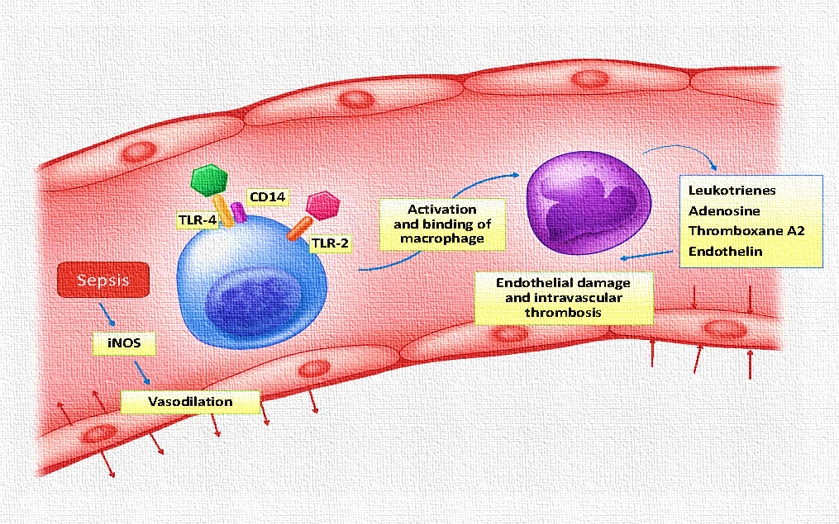

Diagnostic Challenges in Sepsis
Despite advances in our understanding of the disease’s mechanisms, it remains difficult to apply these lessons clinically toward early diagnosis and treatment.
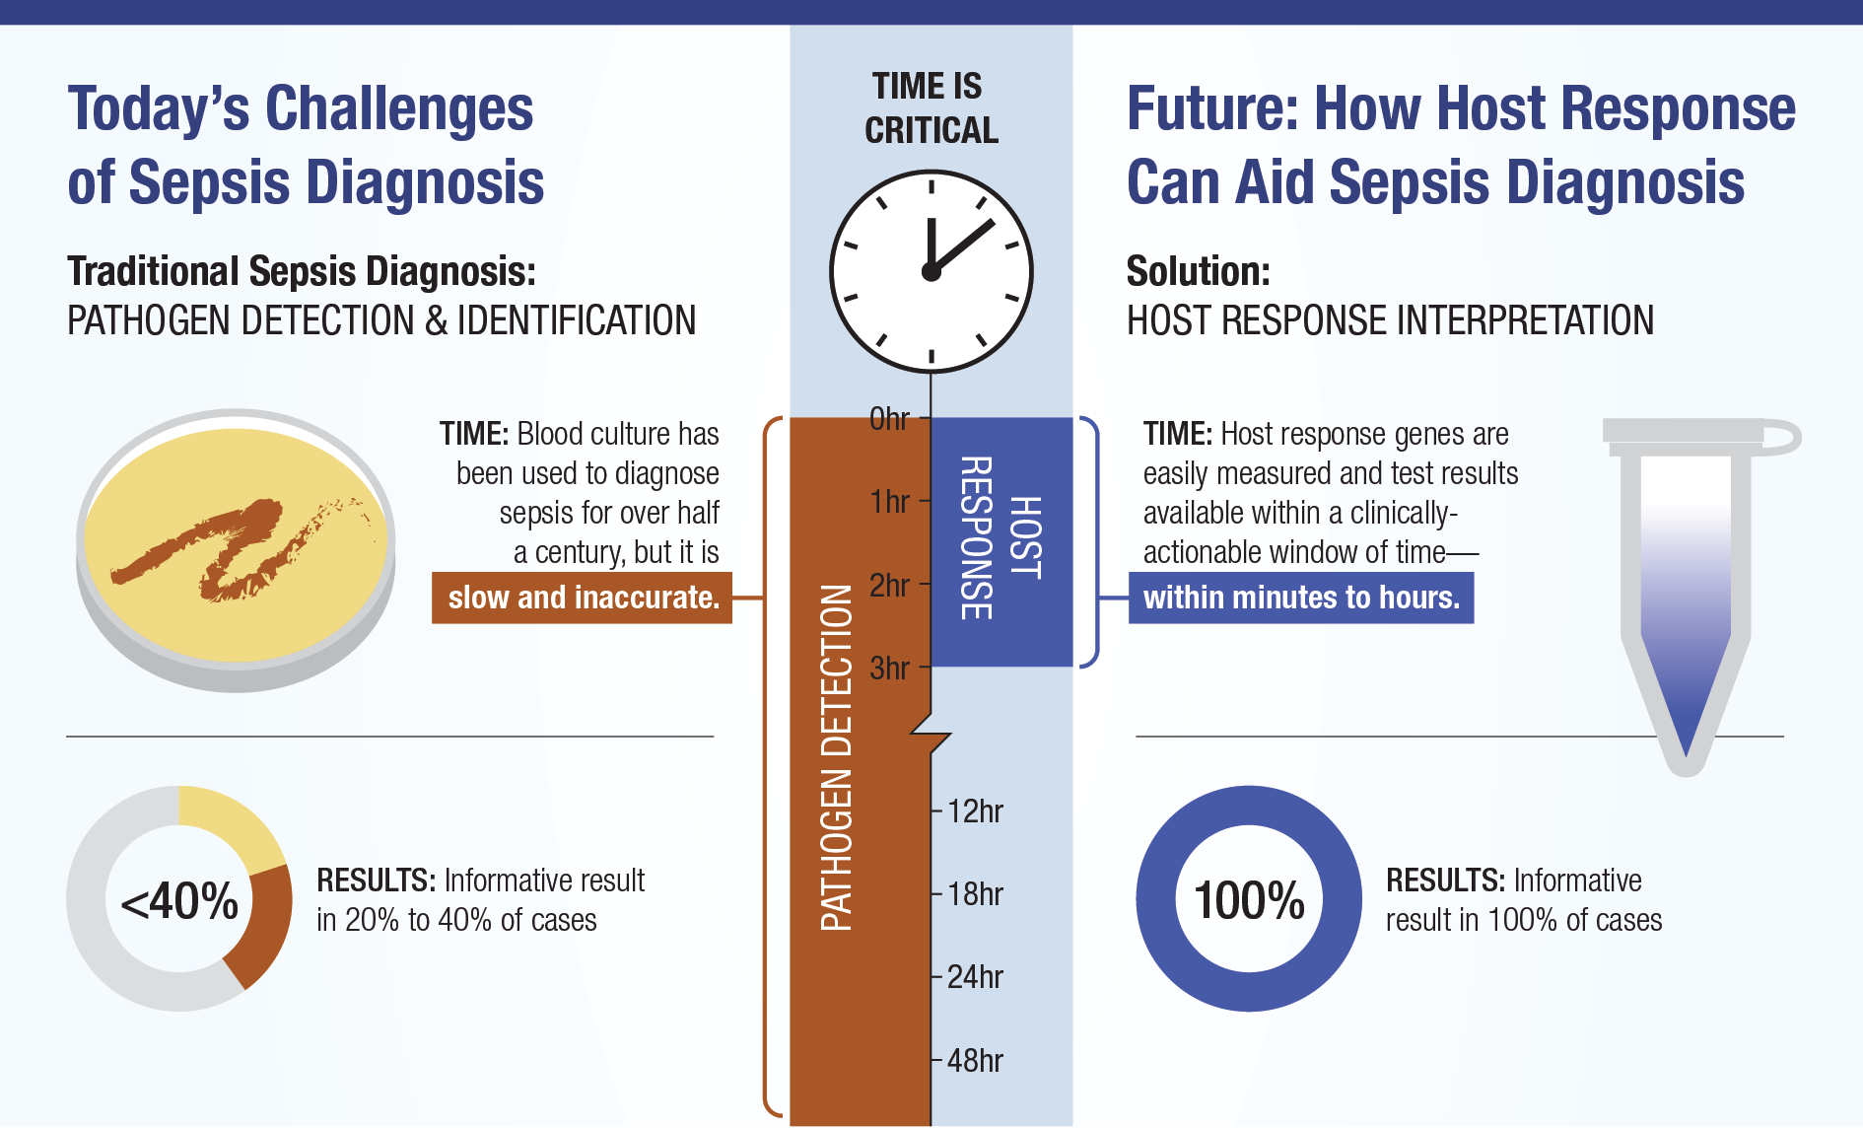
Management of Severe Sepsis: A New Standard of Care
Evidence supporting each element of the bundles is beyond the scope, but some key discussion points follow.

Appropriate Antibiotics

Broad-spectrum intravenous antibiotics should be administered promptly after appropriate cultures are obtained. Although it is widely recognized that failure to initiate adequate antimicrobial coverage results in adverse outcomes [6,7], recent epidemiologic studies have shown a significant increase in the frequency of severe sepsis from polymicrobial infection [8]. Multidrug-resistant bacteria, such as Pseudomonas species and methicillin-resistant Staphylococcus aureus, as well as other Gram-positive and fungal organisms, are also increasing [9]. Knowledge of these changing microbiologic patterns, as well as host and local patterns of susceptibility, are critical in selecting initial therapy. Institution of timely antimicrobial therapy is equally important in the care of the patient with sepsis.

EGDT
EGDT is considered a critical intervention in the early treatment of patients with severe sepsis.
Early Goal Directed Therapy [EGDT] Algorithm/Driver Diagram
Early Identification and Diagnosis | Treatment/Management | Treatment Goals
Symptoms of Sepsis Include:  The patient has 2 or more SIRS criteria:  - HR > 90  - RR > 20  - Change in LOC  - Temperature > 100.4 F [38.0 C] or < 96.8 F [36.0 C]  - WBC > 12, 000 or < 4,000  AND  - Known or suspected infection, for example:  - Cloudy, foul smelling urine  - Wound with drainage or pus  - Cough with green, yellow, brown sputum  If the patient arrives to the ED with these symptoms, or develops these symptoms while staying in the hospital, then blood cultures and lactate levels are drawn and close monitoring of the blood pressure is done to help confirm the diagnosis.  Lab results can confirm a Sepsis diagnosis:  - Positive blood, urine, or sputum culture  - Lactate > 4  - SBP < 90 for more than 1 hr | If a Sepsis diagnosis is determined, EGDT is started when the patient’s lactate result is > 4 or 1 hr after SBP is < 90 if it remains < 90 after 1 hr  EGDT treatment includes:  - Antibiotics  - Sepsis catheter  - Intravenous [IV] Fluids  - IV medication  - Norepinephrine for low MAP  - Dobutamine to help with oxygen delivery [low ScvO₂]  - Blood if Hct< 30  - Repeat lactate test | - Give antibiotics within 1 hr of EGDT start time  - Sepsis catheter is inserted within 2 hours of EGDT start time  - CVP is 8-12 within 6 hr of EGDT start time [fluids used to reach target].  - Once CVP target is met focus on meeting MAP goal  - MAP > 65 within 6 hours of EGDT start time [fluids and Norepinephrine can be used to reach target]  - Once MAP target is met focus on meeting ScvO₂ goal  - ScvO₂ > 70 within 6 hours of EGDT start time [blood and Dobutamine can be used to reach target]  - Draw lactate every 6 hours for 24 hours, goal is that lactate is less than original value within 12 hours of 1st result

Vasopressin

For patients who have been fluid resuscitated, have achieved optimal central venous pressure, and continue to have vasopressor refractory shock, consideration can be given to adding low-dosage, time-limited vasopressin. Before using a vasopressor in a patient with septic shock, ensure that adequate fluid resuscitation has been performed. If a fluid challenge fails to restore an adequate arterial pressure and effective organ perfusion, therapy with vasopressor agents should be started to promote the achievement of a mean arterial pressure [MAP] of 65 or greater. Norepinephrine is frequently chosen as a vasopressor. For the safe use of vasopressors, central venous access is essential, and arterial blood pressures should be closely monitored.
In early sepsis, there is an excess of endogenous vasopressin. Ultimately, levels return to normal range, creating a state of relative vasopressin insufficiency in the patient with severe septic shock [10]. When appropriate, the addition of vasopressin allows for a reduction in standard vasopressors and may improve urine output and creatinine clearance [11]. It should be used with caution in patients who are at risk for cardiac ischemia and low cardiac output. The dosage in clinical practice is 0.01 to 0.04 U/min, with a usual dosage of 0.03 U/min. There is no advantage to dosage titration beyond 0.04 U/min, and some studies have suggested a deleterious impact on organ perfusion at higher dosages.

Corticosteroids

There is controversy surrounding the use of corticosteroids in severe sepsis. The appropriate dosage and timing of therapy, as well as how best to evaluate the adrenal axis, has been studied and debated. High-dosage corticosteroids [300 mg/d hydro-cortisone] are not recommended and may cause harm [12]. There has been a renewed interest in corticosteroids as we have come to understand sepsis as a state of relative adrenal insufficiency, albeit a state that is difficult to diagnose and define on the basis of various measurements of cortisol secretion [13].

APC

Therapeutic attempts to target the procoagulant nature of sepsis have been disappointing [14,15], with the exception of drotrecogina[activated] or recombinant human APC [rhAPC]. This may be due in part to alternative mechanisms of action. Recalling the pathophysiology of severe sepsis, rhAPC has antiapoptotic and anti-inflammatory activity and modulates endothelial dysfunction [16,17]. rhAPC is approved for the treatment of severe sepsis in patients with a high risk for death [defined as an APACHE II score 25], sepsis-induced multiple organ failure, septic shock, or sepsis-induced ARDS.
Patients who had ESRD, bleeding risk and were on HD were also excluded. Although considerable controversy exists, current consensus guidelines recommend rhAPC[18]. In the appropriate clinical setting, rhAPC should be considered in the treatment of severe sepsis. It is recommended that hospitals develop a standardized policy to guide the use of rhAPC. Bedside assessment should inform decisions about risk assessment. Once a patient is determined to be at high risk for death, infusion of rhAPC should begin. Benefits of treatment are seen irrespective of pathogen or site of infection [19], and the drug is cost-effective [20] when used appropriately.

Mechanical Ventilation

Acute lung injury [ALI] or ARDS complicating severe sepsis or septic shock should be managed with a goal to avoid large tidal volumes and elevated plateau pressures. This strategy may occur at the expense of a normal pH and partial pressure of arterial carbon dioxide [so-called “permissive hypercapnea”]—abnormalities that may be tolerated when modest or offset with sodium bicarbonate infusion when severe.

Supportive measures
Blood product administration
Mechanical ventilation of sepsis-induced ARDS
Sedation, analgesia, and neuromuscular blockade in sepsis
Glucose control
Renal replacement therapy
Deep vein thrombosis prophylaxis
Stress ulcer prophylaxis
Nutrition
Setting goals of care
The following items are no longer recommended in this setting: intravenous immunoglobulin, selenium, and bicarbonate therapy.

Considerations for the Nephrologist

The development of acute renal failure is common in severe sepsis and has a significant impact on morbidity, mortality, and cost [21,22]. Administration of bicarbonate does not improve hemodynamic instability, lactic acidosis, or response to vasopressors [23,24], and the use of low-dosage dopamine does not provide sustainable renal protection or improve outcomes in critically ill patients [25,26]. Although the use of erythropoietin has not been studied specifically in severe sepsis, it has been shown to reduce transfusion requirements in critical illness but has no effect on outcome [27,28]. It is therefore not recommended for patients with sepsis.

Future Directions

The future management of sepsis will most likely involve therapies directed at newer inflammatory targets. Another important area of ongoing and future research is endothelial cells and the microcirculation. Better insight into endothelial cell and microcirculatory dysfunction may direct interventions that will facilitate enhanced restoration of tissue perfusion, a primary pathophysiologic lesion in the inflammatory process that contributes to multiorgan failure and cellular dysfunction in sepsis.

Conclusions

Severe sepsis and septic shock are common and increasing among the critically ill. The opportunity now exists for clinicians to adopt an evidence-based approach to diagnosis and management. Mortality may be reduced by focusing on early diagnosis, targeted management, and standardization of the care process.

Take Home Message
Sepsis is one of the most important and high risk diagnosis we commonly face. The definition of sepsis and septic shock has evolved again. Our tools for identifying and managing sepsis have improved but early aggressive treatment has a significant mortality benefit.The goal is to give our physicians the support they need to get their patients the best outcomes possible. If there is any doubt about a patient’s status, please call for a critical care consultation or for the Rapid Response Team as soon as possible.

References
- Angus DC, LindeZwirble WT, Lidiker J, Clermont G, Carcillo J, Pinsky MR. Epidemiology of severe sepsis in the United States: Analysis of incidence, outcome and associated cost of care. Crit Care Med.2001;29:1309–10.
- Alejandria MM, Ann M, Lansang D, Fonbuena GE, Fadreguilan E, Timbreza F, et al. Epidemiology and predictors of mortality from sepsis in medical patients at UPPGH.Phil J Microbiol Infect Dis. 2000;29:23–32.
- Moss M. Epidemiology of sepsis: Race, sex, and chronic alcohol abuse. Clin Infect Dis. 2005;41[Suppl7]:S490–7.
- Todi S, Chattarjee S, Bhattacharyya M. Epidemiology of severe sepsis in India. Crit Care. 2007;11[Suppl2]:65.
- BrunBuisson C, Doyon F, Carlet J, Dellamonica P, Gouin F, Lepoutre A, et al. Incidence, risk factors,and outcome of severe sepsis and septic shock in adults. A multicenter prospective study in intensive care units. French ICU Group for Severe Sepsis. JAMA. 1995;274:968–74.
- Leibovici L, Shraga I, Drucker M, Konigsberger H, Samra Z, Pitlik SD: The benefit of appropriate empirical antibiotic treatment in patients with bloodstream infection. J InternMed 244: 379 –386, 1998
- Ibrahim EH, Sherman G, Ward S, Fraser VJ, Kollef MH: The influence of inadequate antimicrobial treatment of bloodstream infections on patient outcomes in the ICU setting. Chest 118: 146 –155, 2000
- Annane D, Aegerter P, JarsGuincestre MC, Guidet B: Cur-rent epidemiology in septic shock: The CUB-REA Net-work. Am J RespirCrit Care Med 168: 165–172, 2003
- Martin GS, Mannino DM, Eaton S, Moss M: The epidemiology of sepsis in the United States from 1979 –2000. N EnglJ Med 348: 1546 –1554, 2003
- Sharshar T, Blanchard A, Paillard M, Raphael JC, Gajdos P, Annane D: Circulating vasopressin levels in septic shock. Crit Care Med 31: 1752–1758, 2003
- Patel BM, Chittock DR, Russell JA, Walley KR: Beneficial effects of short-term vasopressin infusion during severe septic shock. Anesthesiology 96: 576 –582, 2002
- Bone RC, Fisher CJ, Clemmer TP, Slotman GL, Metz CA: A controlled trial of high-dose methylprednisolone in the treatment of severe sepsis and septic shock. N Engl J Med.653– 658, 1987
- Marik PE, Zaloga GP: Adrenal insufficiency during septic shock. Crit Care Med 31: 141–145, 2003
- Warren BL, Eid A, Singer P, Pillay SS, Carl P, Novak I, Chalupa P, Atherstone A, Pe´nzes I, Ku¨ bler A, Knaub S, Keinecke HO, Heinrichs H, Schindel F, Juers M, Bone RC, Opal SM: High dose antithrombin III in severe sepsis. JAMA 286: 1869 –1878, 2001
- Abraham E, Reinhart K, Opal S, Demeyer I, Doig C, Rodriguez AL, Beale R, Svoboda P, Laterre PF, Simon S, Spapen H, Stone J, Seibert A, Peckelsen C, De Deyne C, Postier R, Pettila¨ V, Sprung CL, Artigas A, Percell SR, Shu V, Zwingelstein C, Tobias J, Poole L, Stolzenbach JC, Creasey AA: Efficacy and safety of tifacogin (recombinant tis-sue factor pathway inhibitor) in severe sepsis: A randomized control trial. JAMA 290: 238 –247, 2003
- Joyce DE, Gelbert L, Ciaccia A, DeHoff B, Grinnell BW: Gene expression profile of antithrombotic protein C defines new mechanisms modulating inflammation and apoptosis. J BiolChem 276: 11199 –111203, 2001
- Mosnier LO, Griffin JH: Inhibition of staurosporineinduced apoptosis of endothelial cells by activated protein C requires protease-activated receptor-1 and endothelial cell protein C receptor. Biochem J 373: 65–70, 2003
- Dellinger RP, Carlet JM, Masur H, Gerlach H, Calandra T, Cohen J, Gea-Banacloche J, Keh D, Marshall JC, Parker MM, Ramsay G, Zimmerman JL, Vincent JL, Levy MM: Surviving Sepsis Campaign guidelines for management of severe sepsis and septic shock. Crit Care Med 32: 858 – 873, 2004
- Opal SM, Garber GE, LaRosa SP, Maki DG, Freebairn RC, Kinasewitz GT, Dhainaut JF, Yan SB, Williams MD, Gra-ham DE, Nelson DR, Levy H, Bernard GR: Systemic host responses in severe sepsis analyzed by causative microorganism and treatment effects of drotrecoginalfa (acti-vated). Clin Infect Dis 37: 50 –58, 2003
- Angus DC, Linde-Zwirble WT, Clermont G, Ball DE, Bas-son BR, Ely EW, Laterre PF, Vincent JL, Bernard G, van Hout B: Cost-effectiveness of drotrecoginalfa (activated) in the treatment of severe sepsis. Crit Care Med 31: 1–11, 2003
- Angus DC, Linde-Zwirble WT, Lidicker J, Clermont G, Carcillo J, Pinsky MR: Epidemiology of severe sepsis in the United States: Analysis of incidence, outcome, and associated costs of care. Crit Care Med 29: 1303–1310, 2001
- Schrier RW, Wang W: Acute renal failure and sepsis. N Engl J Med 351: 159 –169, 2004
- Cooper DJ, Walley KR, Wiggs BR, Russell JA: Bicarbonate does not improve hemodynamics in critically ill patients who have lactic acidosis: A prospective, controlled clinical study. Ann Intern Med 112: 492– 498, 1990
- Mathieu D, Neviere R, Billard V, Fleyfel M, Wattel F: Effects of bicarbonate therapy on hemodynamics and tis-sue oxygenation in patients with lactic acidosis: A prospective, controlled clinical study. Crit Care 19: 1352–1356, 1991
- Bellomo R, Chapman M, Finfer S, Hickling K, Myburgh J: Low-dose dopamine in patients with early renal dysfunction: A placebo-controlled randomized trial. Australian and New Zealand Intensive Care Society (ANZICS) Clinical Trials Group. Lancet 356: 2139 –2143, 2000
- Friedrich JO, Adhikari N, Herridge MS, Beyene J: Meta-analysis: Low dose dopamine increases urine output but does note prevent renal dysfunction or death. Ann InternMed 142: 510 –524, 2005
- Corwin HL, Gettinger A, Rodriguez RM, Pearl RG, Gubler KD, Enny C, Colton T, Corwin MJ: Efficacy of recombinant human erythropoietin in the critically ill patient: A randomized double-blind, placebo controlled trial. Crit CareMed 27: 2346 –2350, 1999
- Corwin HL, Gettinger A, Pearl RG, Fink MP, Levy MM, Shapiro MJ, Corwin MJ, Colton T: Efficacy of recombinant human erythropoietin in critically ill patients. JAMA 288: 2827–2835, 2002

