INTRAOPERATIVE ANAPHYLAXIS

Dr.V.Thomas.,MDAsst Professor
Department of Anaesthesia
Thanjavur Medical College

INTRODUCTION
Anaphylaxis is a severe life threatening type 1 hypersensitivity reaction occurring in susceptible individuals to regular substances/drugs that are non toxic to the normal population. We anaesthetists use a myriad of drugs in the intra-operative period some of which can cause anaphylaxis in a susceptible patient. The true incidence of intra-op anaphylaxis is difficult to estimate but one latest report from Norway suggests an incidence of 1 in 6000.[1]Inspite of the rare incidence,anaesthetists need to be updated in the emergency management of anaphylaxis because its fatal if mismanaged or inadequately treated. Death due to anaphylaxis accounts for 4.3% of deaths under anaesthesia.[2]

PATHOPHYSIOLOGY
Both anaphylaxis and anaphylactoid reactions are caused by release of vasoactive and inflammatory mediators from degranulating mast cells and basophils. Whereas the degranulation of mast cells is caused by IgE antibody formed in response to the antigen[drug] in anaphylaxis, the degranulation is caused by direct toxicity of the drug on mast cell membrane in anaphylactoid reactions.
The release of mediators like histamine, tryptase and several proteases have the following immediate effect:
1.Cardiovascular – severe hypotension ,circulatory failure and death due to intense vasodilatation
2.Respiratory – Bronchoconstriction and laryngeal edema
3.Cutaneous - Urticaria
However it should be noted that anaphylaxis affects almost all organ systems in the body. Patient may develop gastrointestinal disturbances, conjunctivitis and even DIC as a late manifestation. The reason for multiorgan insult is the released mediators-histamine,tryptase,carboxypeptidase A3, chymase, and proteoglycans. These mediators apart from causing vasodilatation and bronchoconstriction also lead to intracellular activation of cycooxygenase, lipoxygenase and phospholipase A2 pathway thereby producing prostaglandins, leukotrienes, platelet-activating factor,IL-6, the newly recognized IL-33 and TNF-a. With such a myriad of mediators it is no wonder that anaphylaxis causes vasodilatation, vascular inflammation,leaky capillaries and even coagulation disturbances thereby affecting all organ systems.

DIAGNOSTIC CRITERIA
Diagnosis of anaphylaxis in the community setting is defined by the World Allergy Organisation[WAO] as given in the figure below[3]. But diagnosing intra-op anaphylaxis has its own inherent problems due to the anesthetised state and the intraoperative environment as I have discussed below.

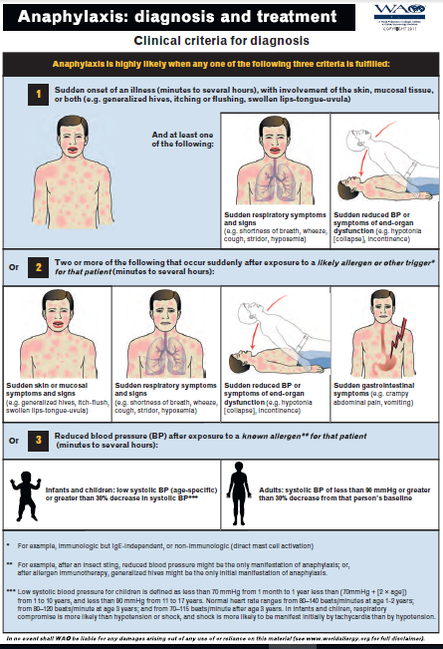

INTRA-OP ANAPHYLAXIS- DIFFICULT TO DIAGNOSE ?
Yes it is. It is difficult to diagnose.
Because anaphylaxis is a rare event that is not the first consideration for the anaesthesiologist ,its management in a full-scale anaesthesia simulator was studied by Jacobsen et alin 2001[4].In this study, none of the 42 anaesthesiologists tested on a simulator made the correct diagnosis during the first 10 min of anaphylaxis, and most of them failed to have a structured plan for its treatment. This 10 minutes delay is significant and can cause mortality.
Patient is draped masking the early cutaneous symptoms, and in case of general anaesthesia patient is unconscious thereby masking the major clues for diagnosing anaphylaxis-pruritus, breathlessness, near syncope and anxiety of impending death that a conscious patient will tell in case of anaphylaxis outside anaesthesia. The difficulty in recognizing anaphylactic symptoms in anesthetized subjects may also be explained by the need to exclude various other clinical conditions:
- Exaggerated drug pharmacological effect[ex:propofol,dexmeditomidine]
- Autonomic parasympathetic effects-peritoneal stretch
- Spinal hypotension-bezold jarisch reflex-Neuraxial cardiac arrest.
- Pulmonary embolism
- Sudden blood loss
- Intra-op Myocardial Ischemia/infarction – fatal arrhythmia.
- Fatal arrhythmias due to non ischemic causes.
- Bronchospasm due to airway irritation.
Based on the scenario at which the sudden hypotension/bronchospasm is happening the anaesthetist has to rule out the above possibilities in a matter of seconds! We don’t have the luxury of a physician ordering a bunch of investigations and sorting out the differential diagnosis in his consultation room. Ours is a different ball game.
The most commonly reported initial features are pulselessness, difficulty in lung inflation and desaturation.[5]

HOW DO YOU MANAGE INTRA-OP ANAPHYLAXIS?
The presentation is often explosive - pulselessness, difficulty in lung inflation and desaturation are the usual presenting features. The clinical scenario at which pulselessness occurs and the monitors like ECG and ETCO2 helps to rule out most of the above differential diagnosis. But the most important thing is to act quickly in any hypotension/desaturation even if the diagnosis of anaphylaxis is not sure but suspected.
Anaphylaxis is a severe form of circulatory shock in which the progression from early shock to progressive and irreversible shock occurs within seconds to minutes. Early shock management is clear and uncomplicated – just improve the preload and myocardial contractility. But the 2nd stage[progressive shock] and 3rd stage[irreversible shock] are complicated because already substantial cellular insult of hypoperfusion has occurred in the myocardium, brain, lung, gut and even in the vascular endothelium. So intervention in anaphylactic shock must be done in the 1ststage[early shock] itself or atleast in the 2nd stage[progressive]. Never delay treatment untill 3rd stage – patient will either die inspite of your treatment or survive with severe neurologic morbidity.
The drug of choice for Anaphylaxis is Adrenaline
IV Adrenaline – 10 to 100mics iv [0.1 to 1mics/kg] must be given within seconds of suspicion of anaphylaxis,and it has to be repeated every minute until peripheral pulse is felt and BP becomes recordable[Monitor carotid pulse until peripheral pulses are felt]. The dose of adrenaline that I have mentioned above is in a wide range because of obvious reasons. The severity at which anaphylaxis presents ranges from mild to severe.
A mild presentation is one in which along with cutaneous symptoms, BP is recordable but there is a fall in BPmore than 30% of his baseline value. Here it is logical to start with small boluses of 10mics iv and titrated to response .On the other end of the spectrum the presentation will be sudden loss of peripheral pulse ,unrecordable BP and a decreasing volume of carotid pulse. This is a pre cardiac arrest situation and it mandates a higher adrenaline dose-100mics IV every 1 minute to prevent a cardiac arrest.[2] Once the circulatory status improves dose should be gradually decreased and a low dose adrenaline infusion can be considered until BP is normal without inotropic/vasopressor support.
It should be noted that the most practical way to monitor the circulatory status in anaphylactic shock is carotid pulse.[5] This is because the carotid pulse decides the dose of adrenaline. Inspite of the severe hypotension [or absent peripheral pulse] if carotid pulse is felt the adrenaline dose is as stated above. On the contrary if carotid pulse becomes absent or doubtful at any point of time then the dose of adrenaline should be increased as per cardiac arrest protocol – 1mg iv every 3mins and CPR should be started.
Adrenaline is a double-edged sword. If inadvertently a cardiac arrest dose of adrenaline [1mg iv bolus undiluted] is given during anaphylaxis [in the presence of spontaneous circulation], patient may die due to ventricular fibrillation, severe hypertension-pulmonary edema,intracerebra lhaemorrhage or myocardial infarction.On the other hand ,if adrenaline is not given, inadequate dose is given or even if delayed for a few seconds to minutes the patient will likely die of hypotension or hypoxia.
Remember the following two rules regarding adrenaline in anaphylaxis
- ANAPHYLAXIS=ADRENALINE.
- THERE IS PRACTICALY NO CONTRAINDICATION FOR ADRENALINE.

Apart from adrenaline the other aspects in the management of intraop anaphylaxis are,[6]
- Immediate discontinuation of suspected drug
- Trendelenburg position to improve venous return
- Rapid infusion of 2 litres normal saline[20ml/kg]
- 100% oxygen
- Consider intubation if patient losing consciousness or desaturating.
- Consider discontinuation of anesthetic drugs that cause hypotension[ex. Volatile agents]

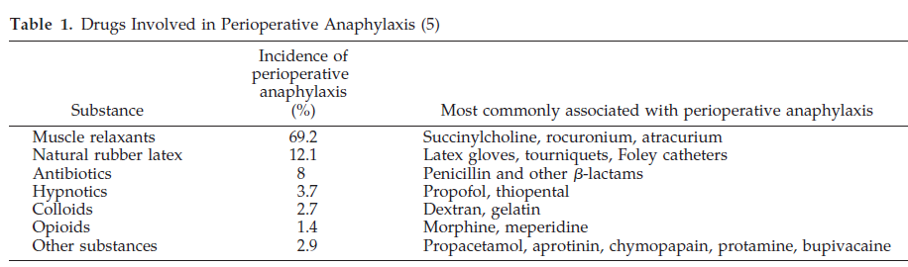

HAVING STABILISED THE PATIENT FROM IMPENDING DEATH WHAT ARE THE FURTHER RESPONSIBILITIES FOR US?
Take blood sample and send for serum tryptase measurement. This test is not universally accepted .However, a small study using serial measurements of tryptase 15 and 60 minutes after a sting challenge found that an increase of at least 2.0 mg/L had a sensitivity of 73% and specificity of 98%.[7] Serum tryptase levels typically begin to increase approximately 30 minutes after the onset of the reaction, peak 1 to 2 hours after the onset of the reaction,and remain elevated for up to at least 6 to 8 hours.
The diagnosis of anaphylaxis and management decisions are purely based on clinical findings. Laboratory testing like serum tryptase and subsequent skin testing are useful only for the future prevention of anaphylactic reaction.[8] Patient should be provided with an ID card that mentions possible drugs that are allergic to him. Patient should be adviced to show this card to the anesthetist in case of any surgeries in the future.

ACKNOWLEDGEMENTS
I sincerely thank my professor Dr.Muthukumaran MD.DA., all the faculties and postgraduates of the Department of Anaesthesia, Thanjavur medical college for their inspiration and help in this manuscript.

REFERENCES
- Fasting S, Gisvold SE. Serious intraoperative problems: A five year review of 83,844 anesthetics. Can J Anaesth. 2002;49:545–53.
- Lieberman P, Kemp SF, Oppenheimer J, Lang DM, Bernstein IL, Nicklas MD. The diagnosis and management of anaphylaxis: An updated practice parameters. J Allergy ClinImmunol. 2005;115(Suppl):S483–523.
- F. Estelle R. Simons,.2012 Update: World Allergy Organization Guidelines for the assessment and management of anaphylaxis:CurrOpin Allergy ClinImmunol 2012, 12:389–399 DOI:10.1097/ACI.0b013e328355b7e4
- Jacobsen J, Lindekaer AL, Ostergaard HT, et al. Managementof anaphylactic shock evaluated using a full-scale anaesthesia simulator. ActaAnaesthesiolScand 2001;45:315–9.
- Levy JH, Yegin A. Anaphylaxis: What is monitored to make a diagnosis? How is therapy monitored? AnesthesiolClin North Am. 2001;19:705–15.
- Whittington T, Fisher MM. Anaphylactic and anaphylactoid reactions. ClinAnaesthesiol. 1998;12:301–23.
- Schwartz LB. Diagnostic value of tryptase in anaphylaxis and mastocytosis.
Immunol Allergy Clin North Am. 2006;26:451e463 (IV).
8. Brown SG, Blackman KE, Heddie RJ. Can serum mast cell tryptase help diagnose
anaphylaxis? Emerg Med Australas. 2004;16:120e124 (III).

